**Project Introduction**

In this project, we will learn about a company's details record and how its related data tables collaborate with the main table. The schema for this project includes six tables: countries, departments, dependents, jobs, locations, regions & employees.

The company's entity relationship diagram is shown in the illustration below. As you can see, the employees table is the parent table, which is linked to countries, departments, dependents, jobs, locations, and regions.

Please take note that, as per the requirement document, below table have 33 data entries or more.

**Project Goal**

The project is aiming to cover all functions learned throughout the timeline of six week classes or otherwise gathered knowledge from personal experiences and self-assessment. It helps appointment fundamental details around creation of table, manipulating data, creating views, Sums, JOINS, aggregate functions, etc.

**Relational Schema**

**Data Table Creation (with SQL) and its Relevant Data Entries:**

Create Queries:

Data Creation for Regions :

Data Creation for Countries :

Data Creation for Departments :

Data Creation for Jobs :

Data Creation for Employees :

Data Creation for Dependents :

**Queries:**

**--**Display employees which has unique department id.

SELECT DISTINCT department_id

FROM employees;

-- Display details of all employees from the employee table in ascending order by their first name.

SELECT *

FROM employees

ORDER BY first_name ASC;

--What are the total salaries payable to employees.

SELECT SUM(salary)

FROM employees;

-- Display the maximum and minimum salary paid to the employees.

SELECT MAX(salary), MIN(salary)

FROM employees;

--What’s the average salary and number of employees are working.

SELECT AVG(salary), COUNT(*)

FROM employees;

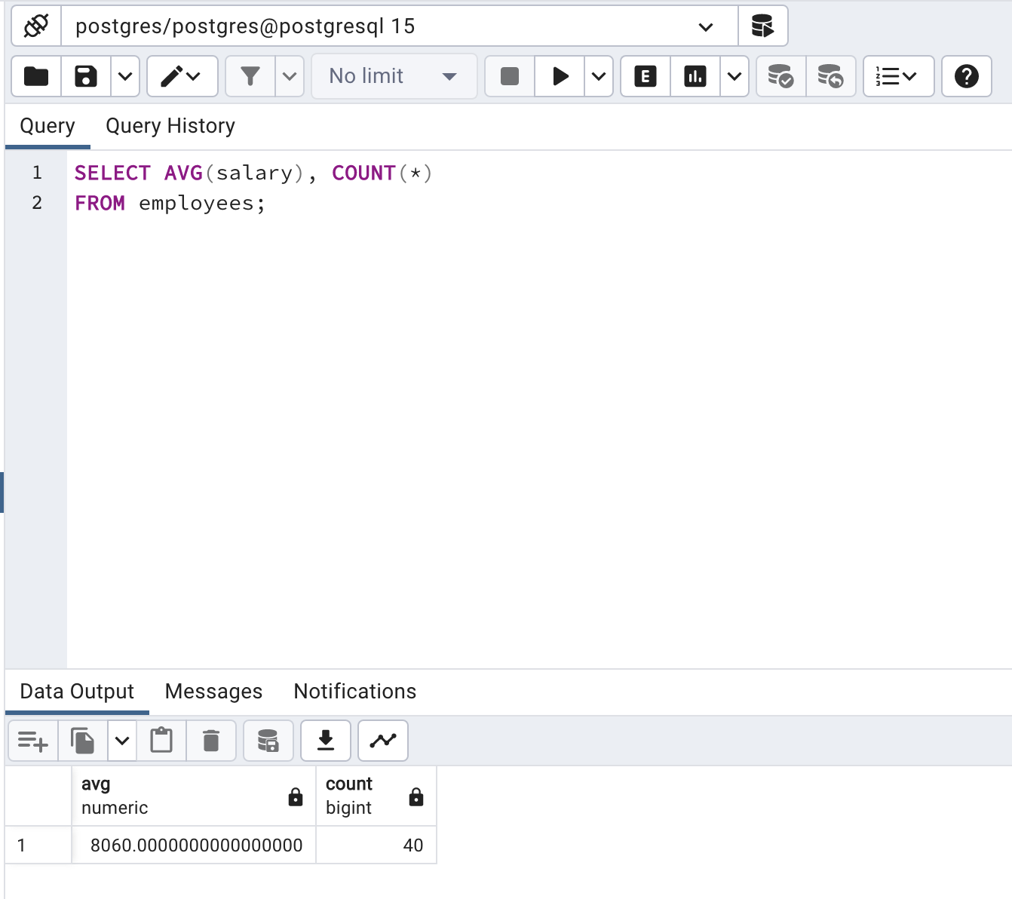

6. Display the first names of employees after removing all the leading and trailing blanks of all the employees from employees table also order by ascending name.

SELECT TRIM(first_name)

FROM employees

ORDER BY first_name ASC;

7. Which employees belongs to which departments including their department ids.

SELECT first_name, last_name, department_id, department_name

FROM employees

JOIN departments USING (department_id);

8. What is the highest, lowest, total, and average salary of all employees of the company.

SELECT ROUND(MAX(salary),0) "Maximum",

ROUND(MIN(salary),0) "Minimum",

ROUND(SUM(salary),0) "Sum",

ROUND(AVG(salary),0) "Average"

FROM employees;

9. What is the number of employees who were hired in year 1987

SELECT first_name, last_name, hire_date

FROM employees

WHERE TO_CHAR(hire_date, 'YYYY') LIKE '%87';

10. What is the total salary payable in each department along with department ID.

SELECT department_id, SUM(salary)

FROM employees

GROUP BY department_id;

References

The sample data for this SQL project was obtained from the website listed below.

*PostgreSQL Exercises, Practice, Solution*. (2022, August 19). w3resource. Retrieved February 25, 2023, from <https://www.w3resource.com/postgresql-exercises/>